How to Print an Object Using FlashForge Finder and FlashPrint software

- In TinkerCAD, select the object you’d like to print and click download.
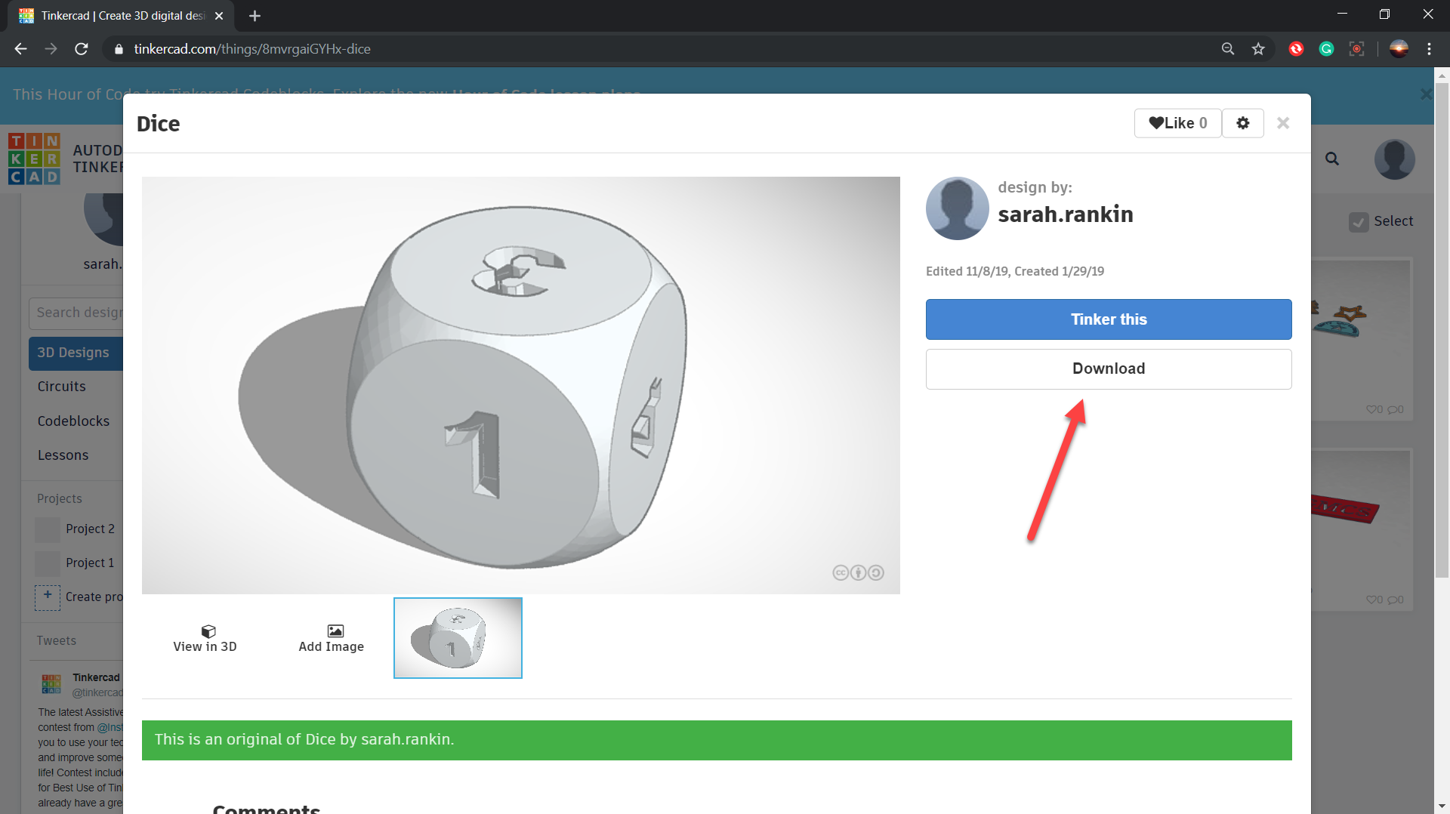

- You’ll be given different options for the file format to be downloaded. Select “.STL”, and the object will be saved to the downloads folder on your computer.
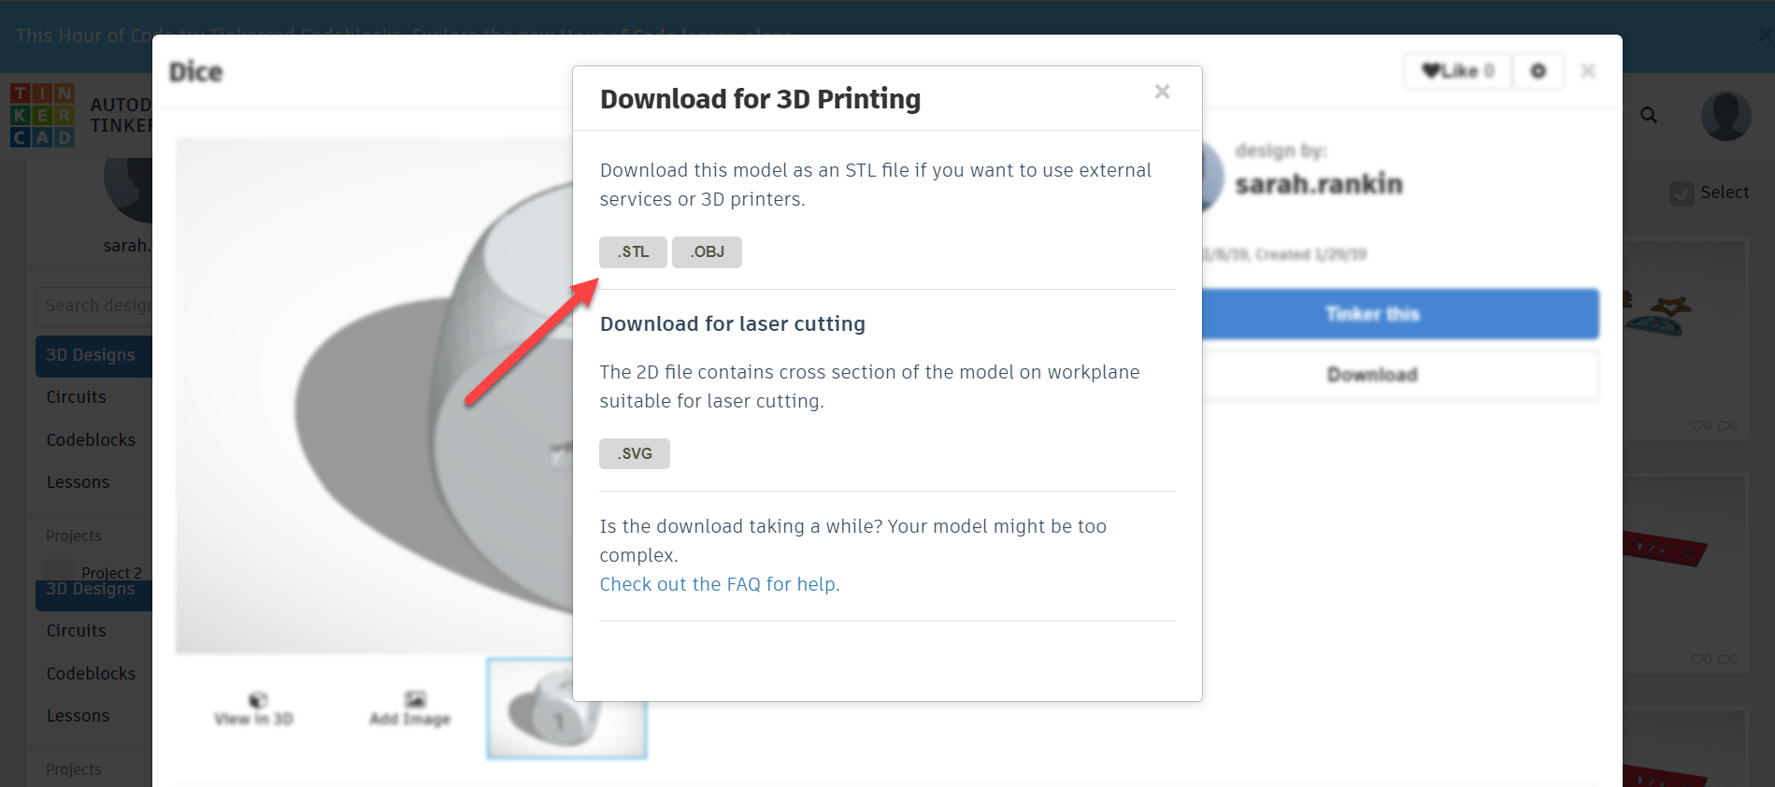

- Open FlashPrint. Once it’s open, click the “LOAD” button at the top of the screen.
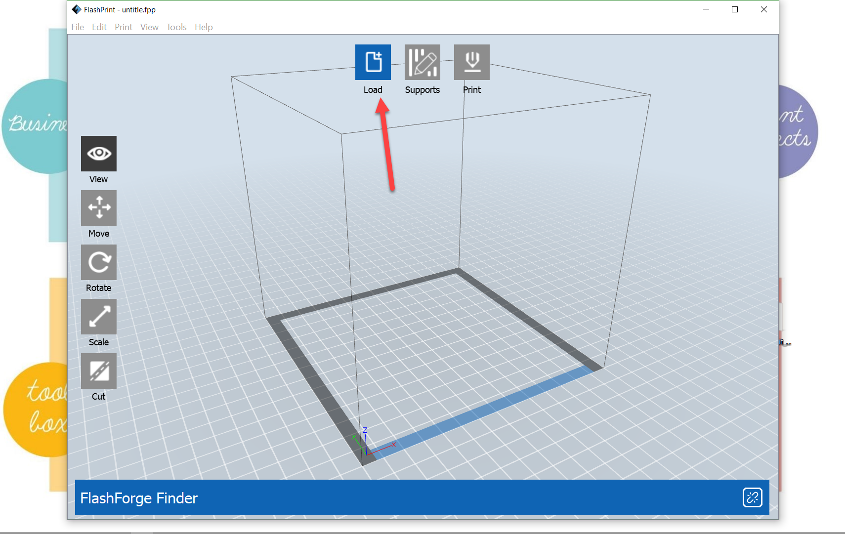

- Navigate to the downloads folder, and select the object that you’d like to print. Click “open”.
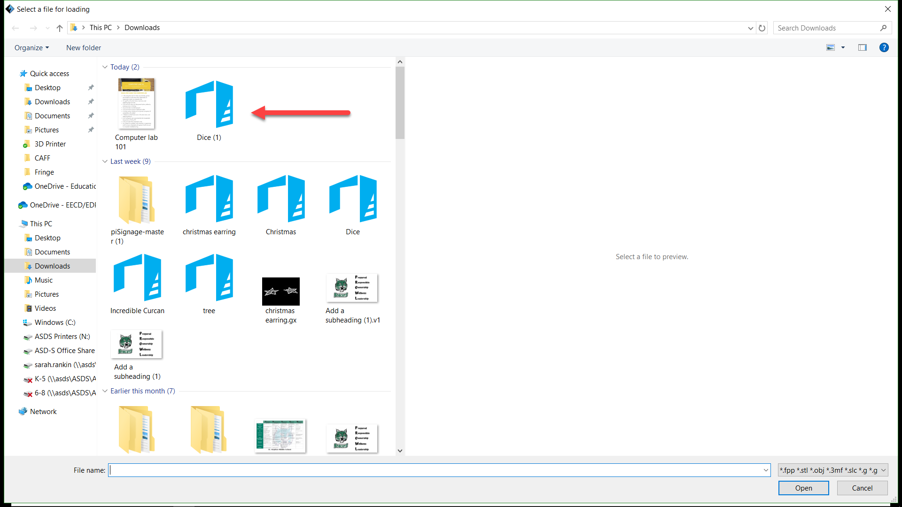
- Once the object has loaded, there are several options for moving, viewing or editing the object.
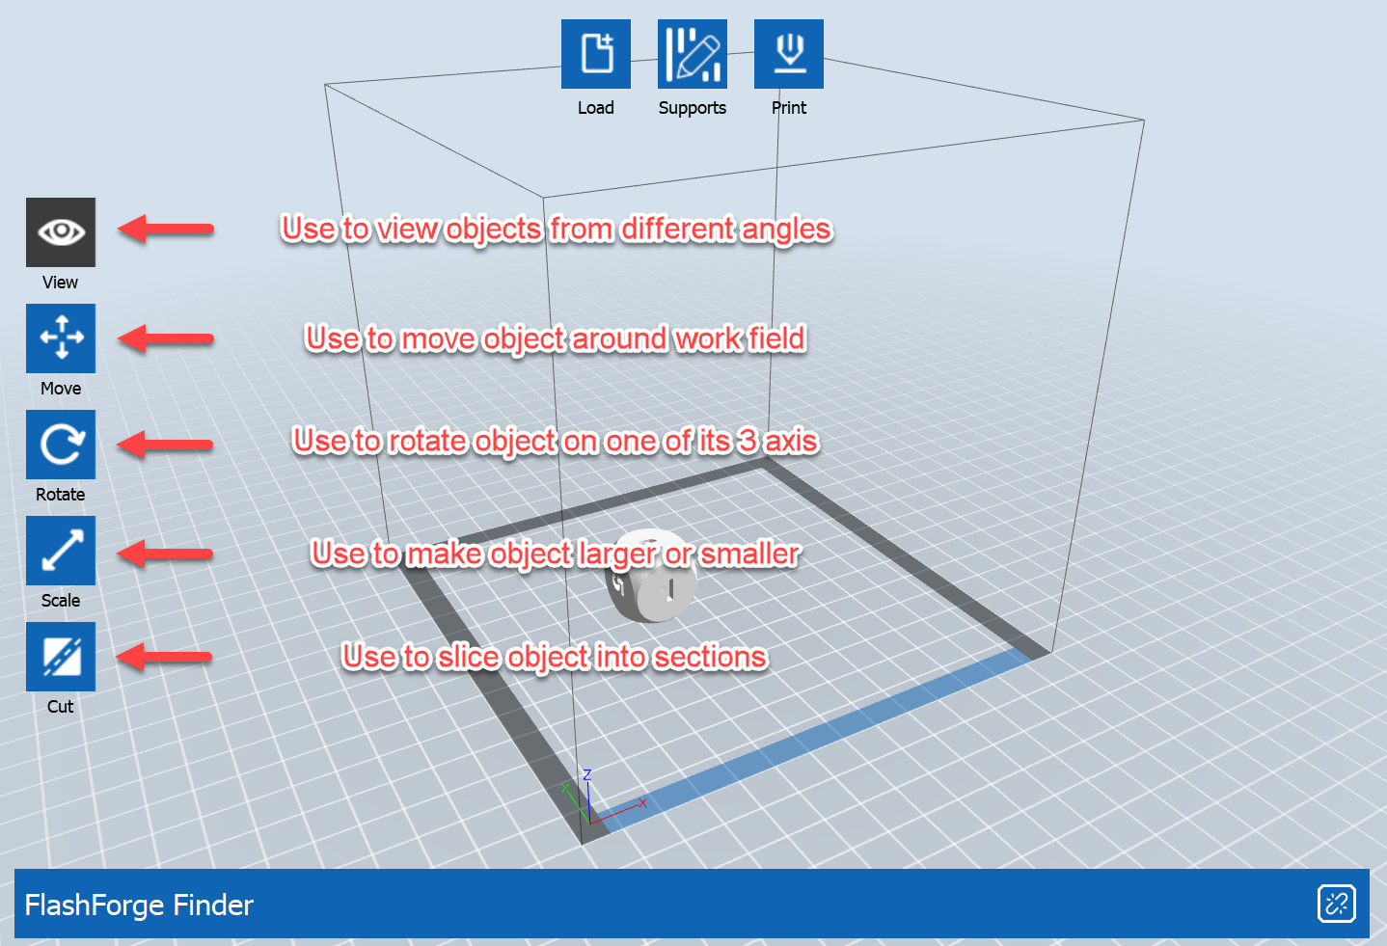

- Once you’re happy with the location, size and look of your object, click “Print”.
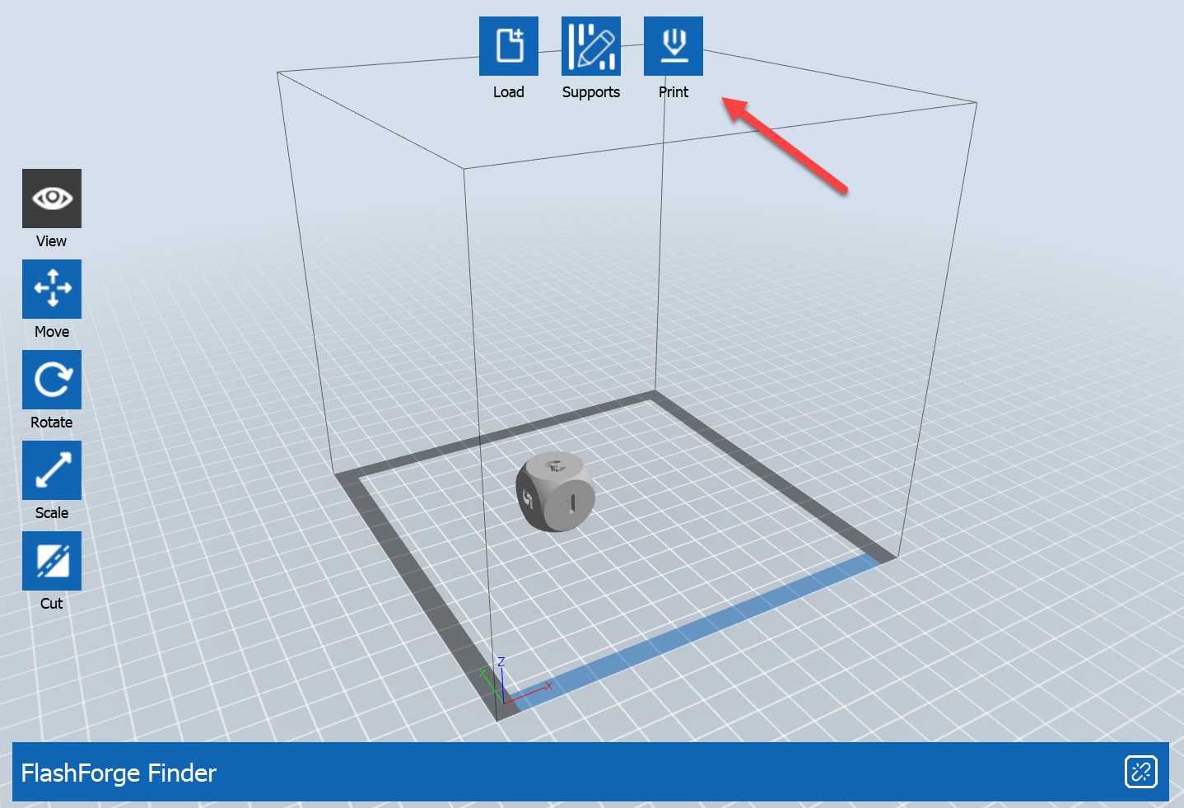
- Depending upon the type of object you’re printing, you may want to add supports or a raft.
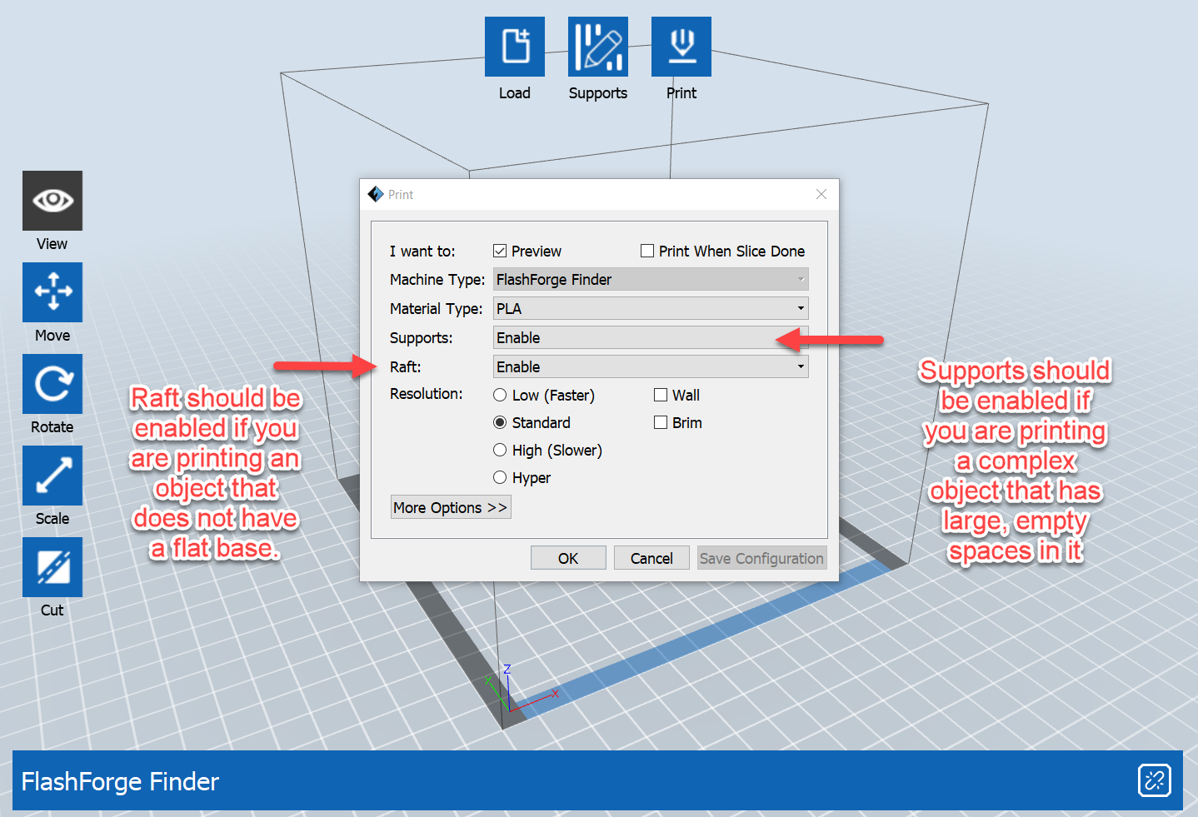

- By clicking on “More Option”, you can choose to adjust the infill of the object.
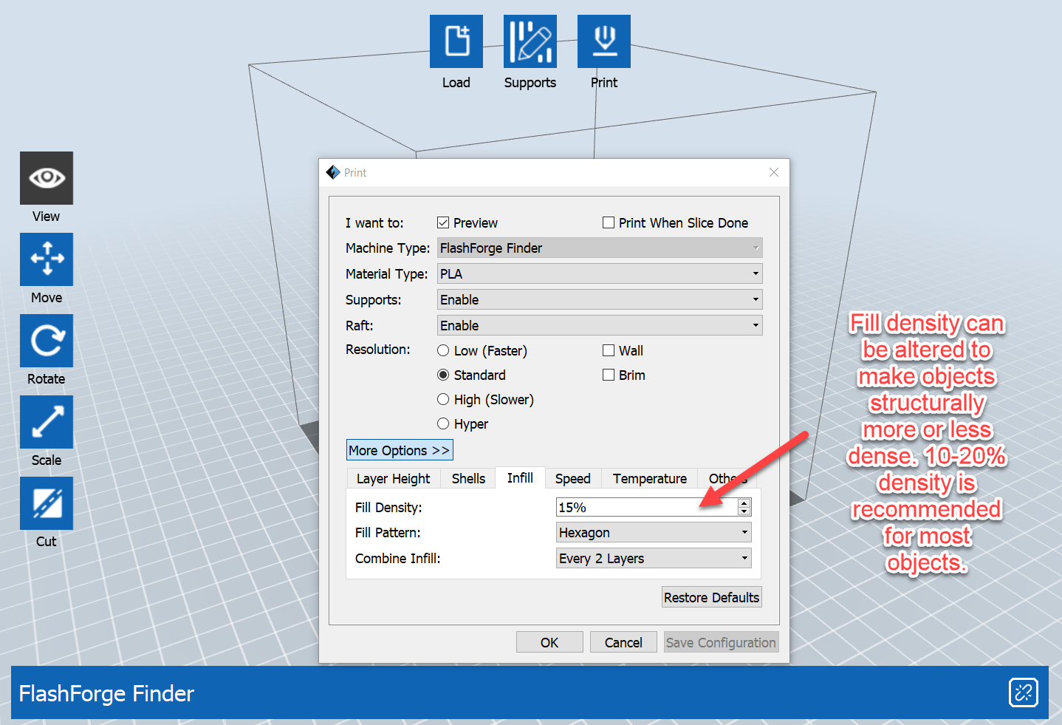
- When you’ve set the fill density, click the box next to “Print When Slice Done”. Slicing is the process of converting the .STL file to a .GX file that the printer can understand.
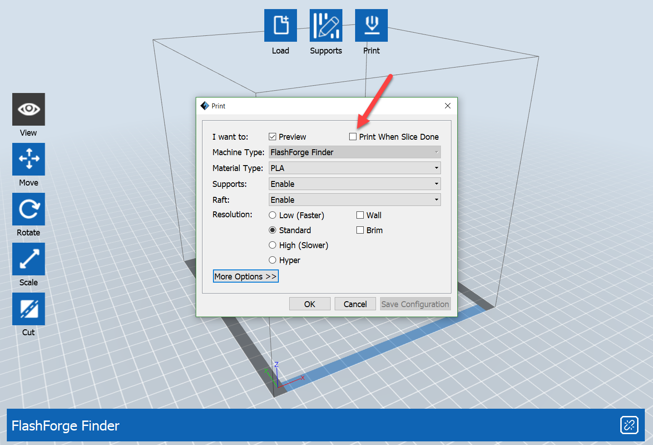

- Connect your computer to the 3D printer via the blue USB cable. Make sure your printer is on and ready to print. Select “USB: FlashForge Finder 3D Printer” and click “Connect”.
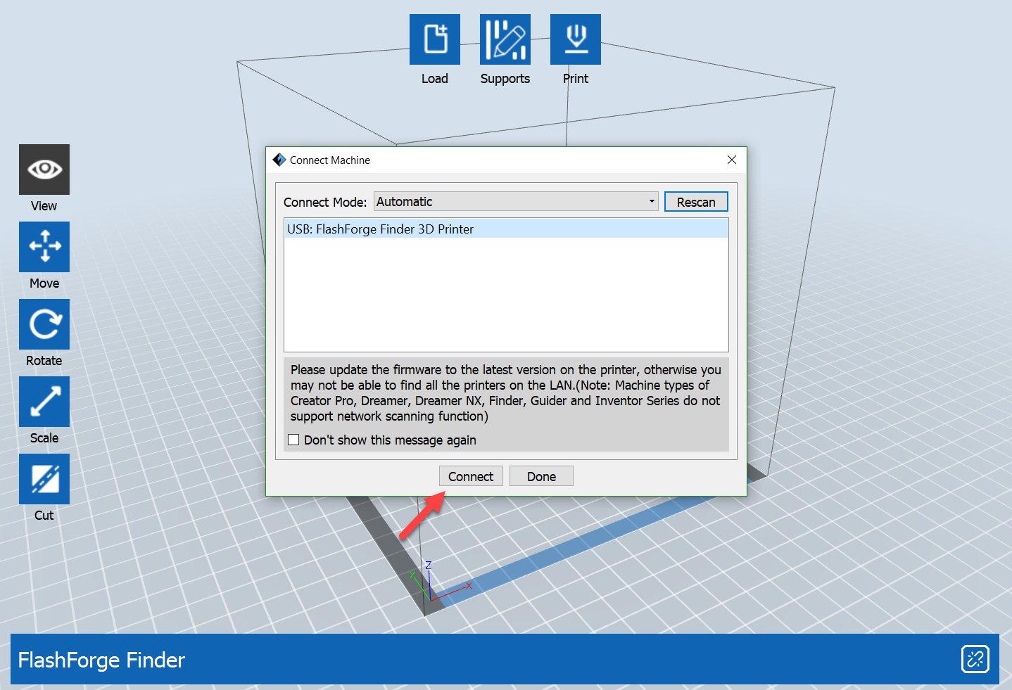
- Click “Ok”. You will be prompted to save your object as a .GX file. Save this file to your OneDrive or to a personal drive on your computer.
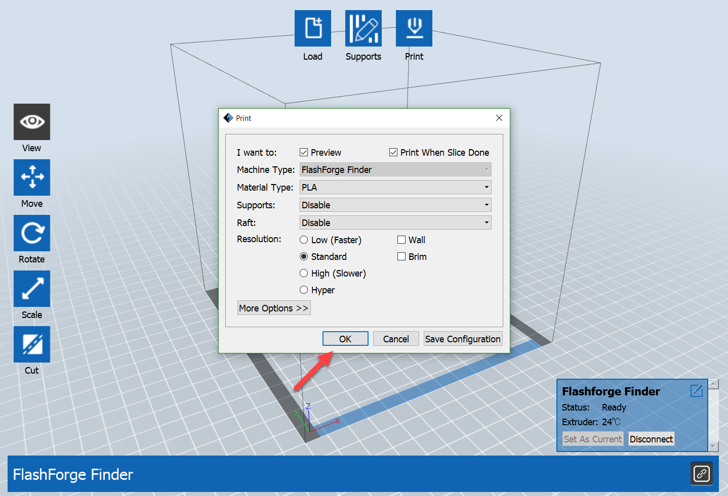

- Your 3D printer will now begin warming up and preparing to print your object. To see show much time it will take and how much filament is being used, check the top right corner of your screen for an estimate.
